- The Monetary Policy Committee voted to cut Bank Rate by 25bps to 4.5% at its meeting this week. Though the vote split appeared dovish at first glance, we think it has little relevance for the monetary policy outlook. Of more importance was the MPC's updated forecasts, which showed inflation above target for nearly three years, and a worse growth-inflation trade-off.
- After December's surprisingly dovish tone, February's meeting sent a more hawkish signal. These mixed messages largely reflect the wide range of views on the committee. For the time being, we maintain our forecast that the MPC will cut rates by a further 75bps in 2025.
The Bank of England's February monetary policy decision was the week's main event, with the Monetary Policy Committee voting 7-2 to cut Bank Rate by 25bps to 4.5%. While the rate cut was fully expected, the vote split was anything but. Catharine Mann – who up until Thursday's vote was widely seen as the MPC's most hawkish member – joined Swati Dhingra in voting for a 50bp cut.
As in the minutes from December's meeting, February's minutes highlighted that the committee was now placing greater emphasis on the softness of recent activity and employment data. However, it was clear that the views among the seven members voting for a 25bp cut varied significantly, with some attributing the weakness in growth to insufficient demand, while others put more weight on the economy's weak supply-side.
The MPC cut its forecast for GDP growth in 2025 to 0.7% from 1.5%, reflecting both the carry-over effect of the poor performance at the end of last year and a downgrade to its projections for H1 2025 (Chart 1). This dropped the MPC's projection under our below-consensus forecast of 1% growth this year (our new UK forecast will be part of our global forecast release on February 11).
Chart 1: The MPC's new growth forecast is weaker than its November projection and our own estimates
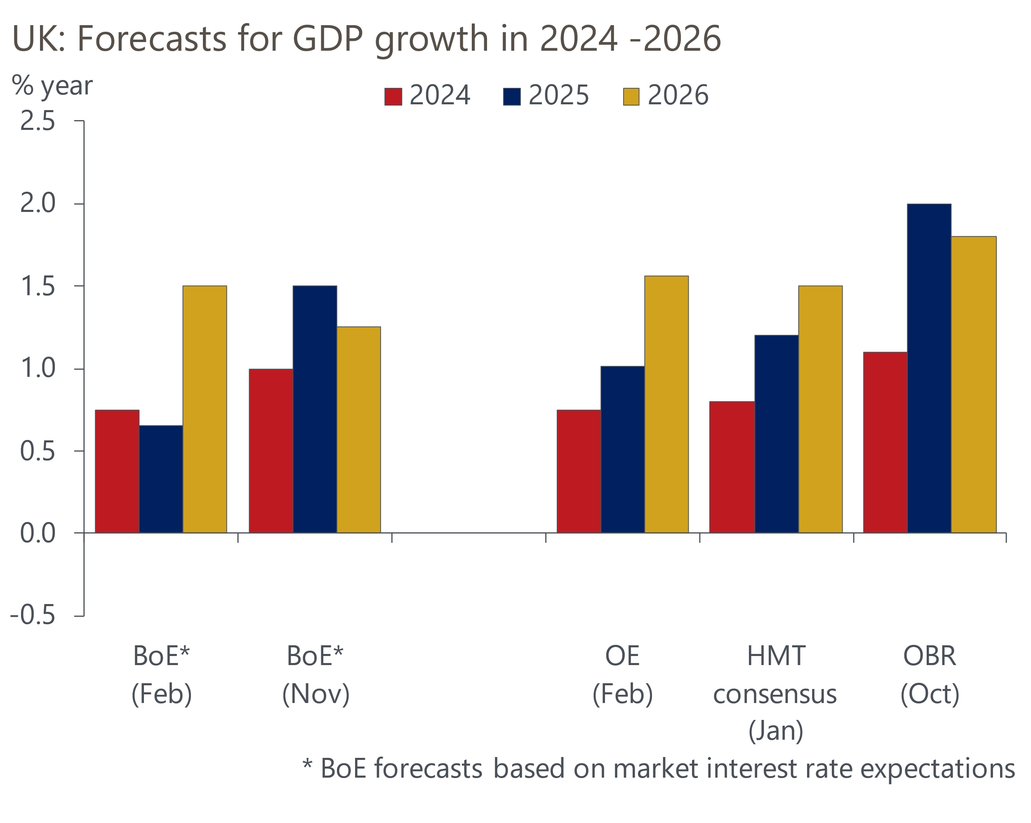
Sources: Oxford Economics, BoE, HMT, OBR

Despite a softer growth forecast, the results of the MPC's annual supply-side stocktake concluded that potential productivity growth has been much weaker than previously anticipated, meaning that very little spare capacity has emerged. This, in combination with a higher assumption for energy prices and a weaker profile for sterling, meant that the MPC lifted its 2025 inflation forecast by 0.75ppts to 3.5%.
Though an increase in the MPC's near-term inflation forecast was expected, and aligned with the signal sent by the prices balance in this week's S&P Global survey, we had thought the medium-term projection would be revised lower. This was because the forecast was conditioned on a market-implied path for Bank Rate that was 40-50bps higher than in November. However, the MPC's new inflation projection was higher across the entire forecast horizon and showed inflation at 2.3% in two years' time, only getting back to the 2% target towards the end of the third year (Chart 2).
Chart 2: The MPC's revised forecast shows inflation above 2% at the two-year policy relevant horizon
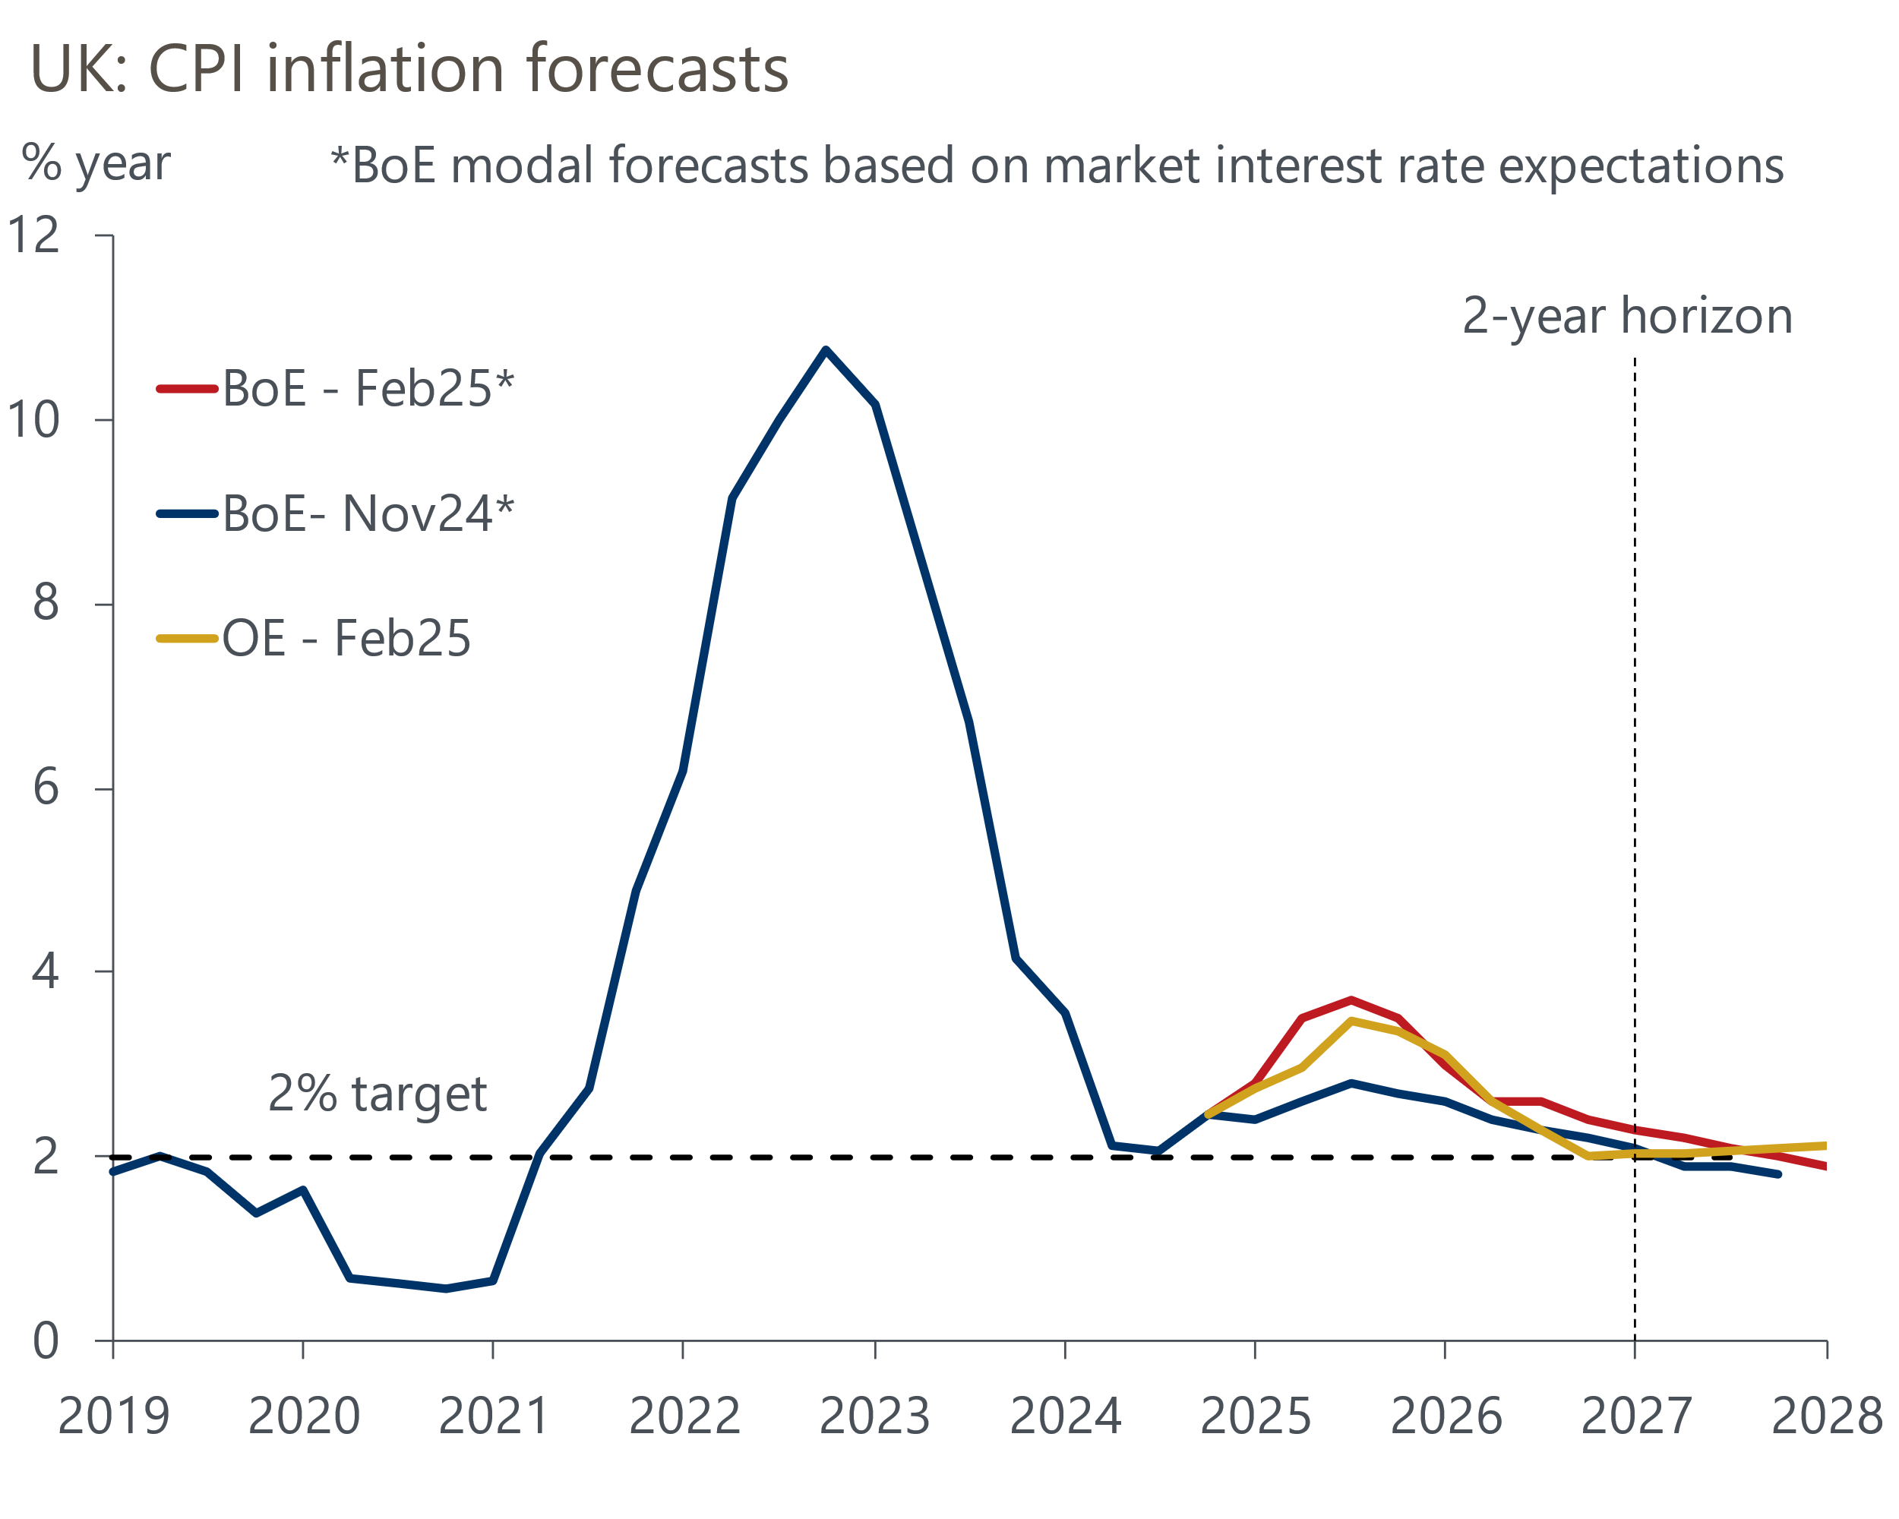
Source: Oxford Economics, Bank of England Monetary Policy Report
The key message from the MPC's new forecasts appears to be that the UK's persistently poor supply-side performance means the growth-inflation trade-off has worsened. This was consistent with the minutes placing greater emphasis on the most hawkish of the MPC's three inflation scenarios, which says that structural shifts in the economy mean that elevated inflation will persist unless there is a period of weak GDP growth and a marked rise in unemployment.
The Monetary Policy Report also revealed that the Bank's annual pay survey suggested that settlements in 2025 are expected to average 3.7%, which is at the upper end of the 2-4% range previously indicated by the Bank's Agents. And while the committee stuck with the guidance that it will likely loosen policy "gradually", it made a point of adding the word "careful" when discussing its approach and emphasised the two-sided risks around the monetary policy outlook.
That the MPC wanted to convey a more hawkish message was reaffirmed by BoE Governor Andrew Bailey's interview with Bloomberg on Thursday afternoon. After markets had initially responded dovishly, Bailey cautioned investors not to put too much weight on the voting as the split "is not a communication tool". He also encouraged the market to "read the minutes pretty carefully this time". This interview triggered a modest repricing, with the 2-year gilt yield ending Thursday slightly higher than it had started the day.
One way of reading the MPC's communications is that it's trying to stress that the 'cut-hold' tempo that's been established over the past six months shouldn't be taken as given, and there is some jeopardy at every meeting. But on balance, we still think the most likely outcome is that the 'cut-hold' tempo continues, with 25bp cuts in May, August, and November leaving Bank Rate at 3.75% at the end of 2025.

The week ahead
Next week's only major release is the GDP data for December. Activity rose modestly in November, due to a small uptick in activity in the consumer-facing services and construction sectors. We expect these sectors to have held on to their gains in December, while November's weak manufacturing reading probably unwound. Overall, we estimate that GDP grew by 0.2% m/m in December. Absent revisions, this would leave GDP flat in Q4 as a whole.
Table 1: Week ahead calendar
Date | Events | Period | Measure | Unit | Previous | Forecast
Feb 13 | GDP | Dec | m/m | % | 0.1 | 0.2
Feb 13 | GDP | Dec | 3m/3m | % | 0.0 | 0.0
Feb 13 | Index of services | Dec | m/m | % | 0.1 | 0.2
Feb 13 | Index of services | Dec | 3m/3m | % | 0.0 | 0.1
Feb 13 | Manufacturing output | Dec | m/m | % | -0.3 | 0.3
Feb 13 | Manufacturing output | Dec | y/y | % | -1.2 | -1.8
Feb 13 | Industrial production | Dec | m/m | % | -0.4 | 0.2
Feb 13 | Industrial production | Dec | y/y | % | -1.8 | -2.0
Feb 13 | Construction output | Dec | m/m | % | 0.4 | 0.2
Feb 13 | Construction output | Dec | y/y | % | 0.2 | 1.2
Feb 13 | UK trade | Dec | Trade balance | £bn | -4.8 | -1.7
Feb 13 | UK trade | Dec | Visible balance | £bn | -19.3 | -16.8
Source: Oxford Economics

Key forecasts
Table 2: UK forecast overview
(Annual percentage changes unless specified)
 | 2022 | 2023 | 2024 | 2025 | 2026 | 2027
GDP | 4.8 | 0.4 | 0.8 | 1.0 | 1.6 | 1.7
Private consumption | 7.3 | 0.4 | 1.0 | 1.3 | 1.4 | 1.5
Fixed investment | 5.1 | 0.3 | 1.1 | 0.2 | 3.2 | 2.5
Government consumption | 0.6 | 1.0 | 2.1 | 2.6 | 1.6 | 1.6
Exports of goods and services | 12.6 | -3.2 | -2.5 | -0.8 | 1.2 | 1.5
Imports of goods and services | 13.0 | -4.5 | 1.6 | 0.4 | 1.6 | 1.3
Industrial Production | -6.4 | -0.9 | -1.6 | -0.4 | 1.1 | 1.2
Consumer prices | 9.1 | 7.3 | 2.5 | 3.1 | 2.5 | 2.1
Unemployment rate (%) | 3.8 | 4.1 | 4.3 | 4.5 | 4.5 | 4.3
Current a/c balance (% of GDP) | -2.2 | -2.2 | -2.8 | -3.0 | -2.9 | -2.7
Government balance (% of GDP) | 4.1 | 5.2 | 4.9 | 3.2 | 2.8 | 2.2
Central bank policy rate (%, EOP) | 3.50 | 5.25 | 4.75 | 3.75 | 3.00 | 2.50
10yr govt. bond yield (%, EOP) | 3.67 | 3.54 | 4.57 | 4.31 | 3.89 | 3.44
Exchange rate (US$ per £, EOP) | 1.20 | 1.27 | 1.25 | 1.26 | 1.27 | 1.28
Exchange rate (euro per £, EOP) | 1.13 | 1.15 | 1.21 | 1.19 | 1.19 | 1.19
Source: Oxford Economics
Table 3: Quarterly forecasts for the UK
 | 2024 |  |  |  | 2025
 | Q1 | Q2 | Q3 | Q4 | Q1 | Q2 | Q3 | Q4
GDP (% year) | 0.3 | 0.7 | 0.9 | 1.1 | 0.8 | 0.8 | 1.1 | 1.5
CPI inflation (% year) | 3.5 | 2.1 | 2.1 | 2.5 | 2.7 | 3.0 | 3.5 | 3.4
Bank Rate (%, EOP) | 5.25 | 5.25 | 5.00 | 4.75 | 4.50 | 4.25 | 4.00 | 3.75
10yr gilt yield (%, EOP) | 3.95 | 4.17 | 4.00 | 4.57 | 4.50 | 4.45 | 4.39 | 4.31
US$ per £ (EOP) | 1.26 | 1.26 | 1.34 | 1.25 | 1.23 | 1.24 | 1.25 | 1.26
Euro per £ (EOP) | 1.17 | 1.18 | 1.20 | 1.21 | 1.19 | 1.19 | 1.19 | 1.19
Source: Oxford Economics

Latest Country Economic Forecast:
January 22, 2025

Recent publications

Data Insights
PMIs suggest growth off to a slow start in 2025
January's manufacturing PMI pointed to softer decline in activity
Mortgage approvals picked up a little at the end of 2024
The PMIs started 2025 on a slightly brighter note
Government has little fiscal room for manoeuvre

Research Briefings
MPC cuts rates, but growth-inflation dynamic is worsening
MPC preview – Maintaining the dovish message
A plan for growth - next steps
Labour market data woes show the importance of nowcasts
Three key uncertainties cloud the labour market outlook

Contacts

Oxford Economics' UK team
- Andrew Goodwin - Chief UK Economist - agoodwin@oxfordeconomics.com
- Edward Allenby - UK Economist - eallenby@oxfordeconomics.com

